HOMEWORK
Week of December 10-14, 2018

Vocabulary: Egypt ancient culture pyramid mummy hieroglyph pharaoh Nile

Monday-Thursday

Reading: 1.) Read a book of your choice. Use the menu below to choose 1 book activity.
(Due-Friday)
2.) Please continue to read books. 20 minutes daily.
________________________________________________________________________________

Poster  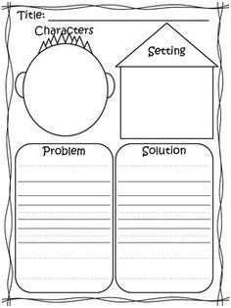  - Create a poster describing your story’s elements.  - Use any size paper or poster. | Puppet  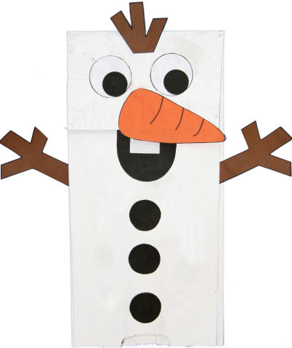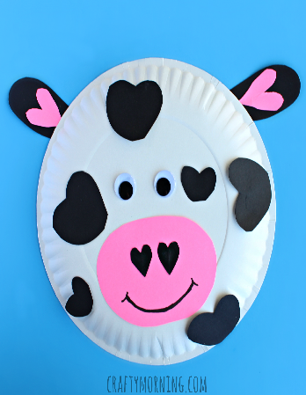  - Choose your favorite character from your book.  - Create your own paper bag or paper plate puppet.

Weekly Reminders:
Friday- Holiday program at 9:00 am. Early dismissal at 12:45 pm.
Monday (12/17)- Holiday party is at 10:00 am. Early dismissal at 12:45 pm
Tuesday (12/18)- **Please know that your child will not miss any academics if you have other obligations on Tuesday, but it will be counted as an absence. **

